ICP-723 Introduction
NTRK (neurotrophic factor receptor tyrosine kinase) gene fusions occurs in various adult and pediatric cancers. A new drug called ICP-723 has demonstrated in the lab and in a small number of patients on clinical trials, that it can be an effective treatment for tumors with NTRK fusions. ICP-723 is an oral, highly selective second-generation pan-TRK inhibitor (inhibits NTRK 1, 2 and 3 gene fusions). It has similar or superior anti-tumor activity when compared with other TRK inhibitor Preclinical data (information shown in the lab, not in human trials) confirmed the anti-tumor effect on NTRK fusions and also showed ICP-723 was able to overcome résistance mutations that can occur from treatment with 1st generation TRK inhibitors (such as Larotrectinib or Entrectinib)
ICP-723 brings a new and exciting treatment option for patients with NTRK fusion-positive cancer.
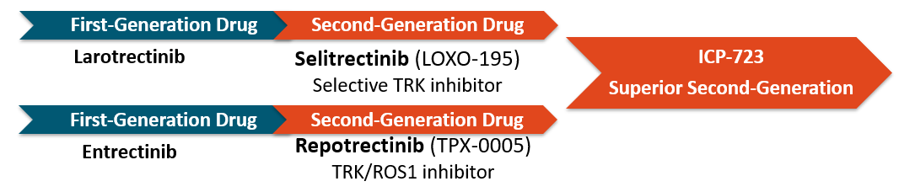
Efficacy - Effective success of ICP-723:
As of (Aug 18 2022 ), 7 ofNTRK fusion positive patients treated with ICP-723 at dose levels of 4 mg and above have shown either stable disease or >30% reduction in their tumor size
Safety - ICP-723 has a low incidence rate of adverse events, similar to what has been reported with other NTRK inhibitors
Listed are most common adverse events (>20%) identified from ICP-723 treatment. Most of the adverse events were mild to moderate. None required patients to discontinue therapy permanently and were managed with supportive measures
Anemia – lack of red blood cells
Increase in Liver Enzymes – increase in liver function
Increase in Creatine Phosphokinase (CPK) - a protein that helps to balance chemical changes in your body and is found if there is possible stress or injury to the muscles
Fatigue – the feeling of being tired or exhausted

ICP-CL-00502 Trial available
A Phase I/II first-in-human (FIH) study of ICP-723 (ICP-CL-00502, ClinicalTrials.gov Identifier: NCT05537987) is currently ongoing in US to define the safety and tolerability in patients with advanced solid tumors
- Sponsor: InnoCare Pharma, Inc.
- Study Centers: Multicenter in US
- Study Phase: Phase I.
- Study Population: Patients with solid tumors that are advanced/metastatic and unresponsive to standard treatments or have relapsed; patients who have progressed under standard treatment including prior treatment with TRK or ROS1 inhibitors. Patients with a documented NTRK fusion or ROS1 fusion will be enrolled with priority.

https://clinicaltrials.gov/ct2/show/NCT05537987?term=NCT+05537987&draw=2&rank=1

